**Installation/Execution Guide:**

**Step1:** Importing Data from MongoDB

mongoimport --db documents --collection catalog --type csv --headerline --file /data/dump/water/WaterqualityIndex.csv

**Step2:** Query the collection

> db.catalog.find()

**Step3:** Once File is exported to the documents and uploaded into the Drive. Open the file with Google COlab along with Python3 Notebook

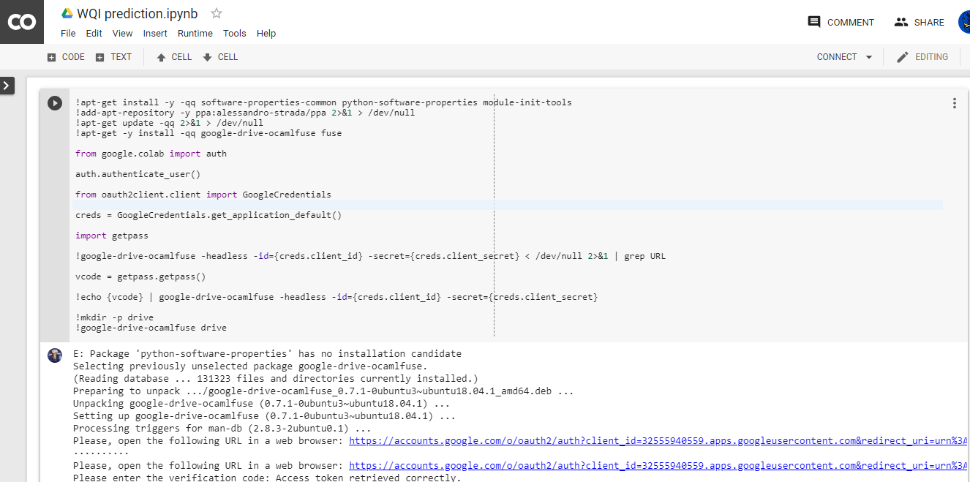

**Step 4:** Change the Directory where the csv file is stored

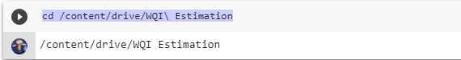

**Step 5:** Import the data to Workbook

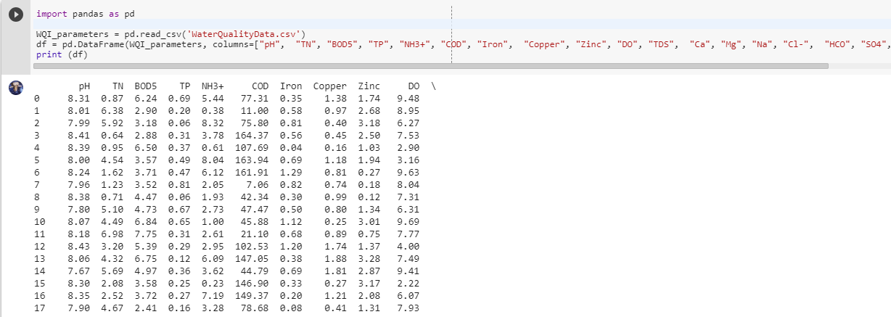

**Step 6:** Set a Plot point on Data



**Step 7:** Calculate Water Quality Index using the values and Formula

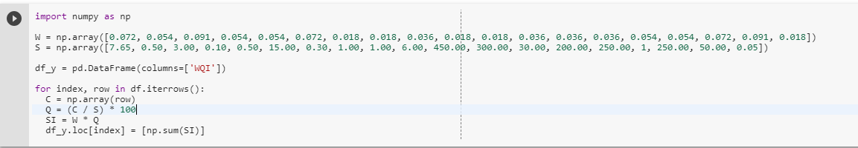

**Step 8:** Plot the graph to check the Scatter

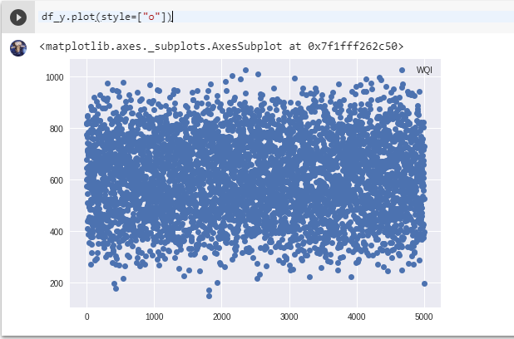

**Step 9:** Check the Index Quality

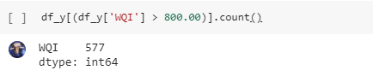

**Step 10:** Import **Keras** to model the Data

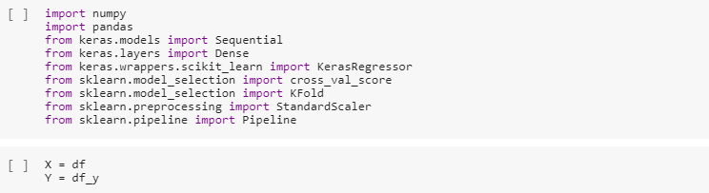

**Step 11:** Create a Base Model to check the Error in WQI

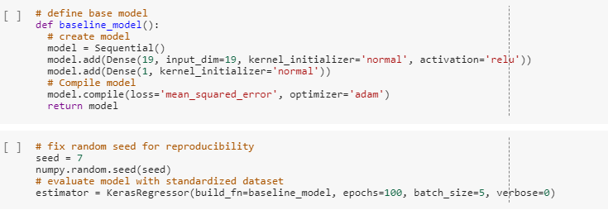

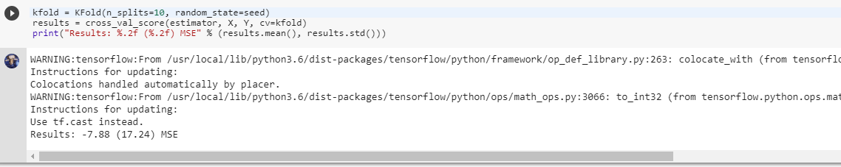

**Step 12:**  Evaluate the model by creating Standardised dataset

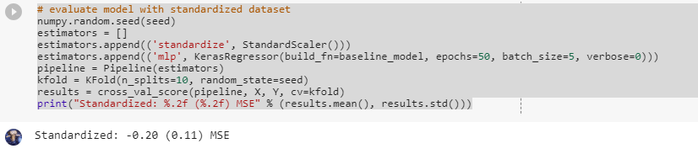

**Step 13:** Apply same steps to create a Larger Model and check the Accuracy of WQI

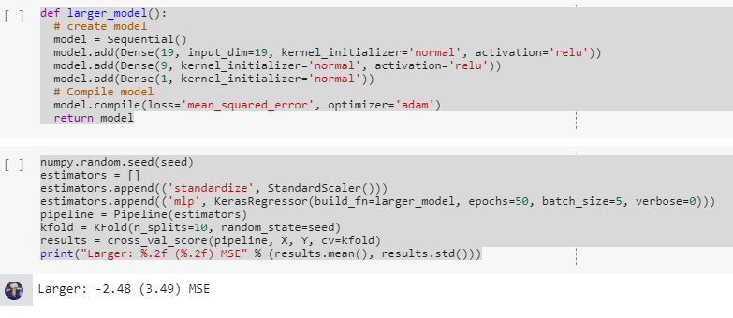

**Conclusion:** Thus, with the help of all the models the WQI is calculated and standard value is being generated and this value can be compared with the WHO Water Quality Standards to check the Purity.